The Irrelevance of Economics in the Business of Investing
“Why keeping things simple prevail”
Aditya Mishra
24 November, 2025

Abstract. This paper argues that most economic theories offer little value to an investor who studies businesses as living, evolving systems. Traditional economics focuses on prediction, equilibrium, and large models, while real investing depends on judgment, patterns, incentives, and the behaviour of individual businesses. The paper explains why investors gain more by reading annual reports, tracking cash flows, and understanding management than by interpreting broad economic forecasts. It also shows how simplicity often produces better decisions than complex frameworks. The aim is to present a practical view of investing that treats businesses as the only true source of insight and treats economics as background noise.

- Introduction
O
ften times, investors are spooked by the conditions of the contemporary state of the economy. Fear or optimism about inflation, deflation, crude oil prices, interest rate decisions, and every other headline variable has forever lingered in every market cycle. Every generation believes its economic environment is uniquely uncertain, and every generation repeats the same cycle of panic, speculation, and misplaced confidence. These emotions seep into the “market” and drive the prices of stocks, sometimes violently, even when the underlying businesses remain unchanged.
As a result, investors grow convinced that understanding contemporary economic affairs holds the key to building “gains”, and that missing a macro shift means missing an opportunity. They feel the need to constantly monitor forecasts, commentaries, and expert opinions, as if these signals reveal something essential about long term compounding. Entire industries have been built around the promise that economic prediction can guide investment outcomes. There are many rebuttals offered whenever the relevance of the economy is questioned. Most of them sound persuasive, and most of them have persisted for decades in one form or another. Yet these arguments rarely hold up when examined through the lens of business fundamentals and long-term ownership. This paper aims to address these claims, challenge the belief that macro awareness leads to superior investing outcomes, and show why a contemporary, economy-first perspective often distracts more than it helps when long term wealth building is the real target.
- The Difference Between Economics and Investing

Economics and investing are often spoken about in the same breath, yet they operate on completely different planes. Economics studies large systems. Investing studies individual businesses. The confusion begins when investors assume that what is true for an economy must also be true for a company. In practice, the link between the two is far weaker than it appears.

Economics deals with aggregates. It observes inflation, GDP, employment, consumption, and tries to explain how millions of decisions interact. The scale is enormous, and the conclusions are broad. These conclusions may be interesting, but they rarely translate into precise, usable insights for an investor. Even the most respected economists struggle to predict the direction of the next quarter, let alone the next decade.

Investing is the opposite. It demands a close study of specific firms, their incentives, their competitive positions, and their behaviour over time. A company can grow earnings even when the economy contracts. A company can destroy value even when the economy booms. The stock of a business reflects its ability to allocate capital, maintain discipline, and serve its customers. None of this is captured by macro statistics.

Economics aims to describe the world in general terms. Investing aims to understand a few businesses deeply. One looks outward at crowds. The other looks inward at decisions. When investors blur these two disciplines, they end up relying on signals that are too broad to guide specific choices. They treat stocks as macro instruments rather than as ownership in businesses.

The purpose of this section is not to undermine the field of economics. It is to clarify that the tools used to understand economies do not naturally extend to understanding companies. The investor’s task is narrower, more focused, and far more practical. Success comes from studying firms, not forecasting nations.

- Why Macroeconomic Predictions Fail.
Macroeconomic predictions fail for a simple reason. They attempt to compress millions of independent human decisions into a single forecast. Economies are not machines with fixed inputs and predictable outputs. They are constantly shifting systems influenced by politics, psychology, incentives, and randomness. No model can fully capture this complexity, yet investors often treat these predictions as if they are precise roadmaps.
Most economic forecasts rely on assumptions that rarely hold true in the real world. Inflation may cool faster than expected. Interest rates may rise slower than projected. Supply chains may recover earlier than feared. A single geopolitical event can undo months of careful modelling. The accuracy of these forecasts is often no better than chance, but the confidence with which they are delivered gives them an air of authority.
Even when predictions turn out to be correct, they rarely translate into actionable investment decisions. Markets often anticipate events long before they occur, and by the time a forecast “comes true,” prices have already adjusted. Acting on macro predictions usually means reacting to something the market has already priced in. The investor ends up chasing narratives instead of studying businesses.
There is also a behavioural cost. Constant attention to economic forecasts creates a sense of urgency that pushes investors toward activity rather than understanding. They feel compelled to respond to every report, every number, and every projection. This reactive mindset damages discipline. It shifts focus from long term ownership to short term interpretation.
The failure of macroeconomic predictions is not a failure of intelligence. It is a failure of expectation. These forecasts were never designed to guide investment decisions at the level of individual businesses. Using them as such leads to decisions based on noise rather than knowledge.

- The Hidden Cost of Contemporary Thinking
Contemporary thinking feels sensible on the surface. It gives investors the illusion of being informed, prepared, and ahead of the curve. But beneath this comfort lies a cost that compounds quietly over time. When investors anchor their decisions to the present state of the economy, they shrink their perspective to whatever the world looks like today. This narrow view prevents them from seeing what actually matters for long term compounding.
The first cost is distraction. Every day brings a new headline, a new number, a new prediction. Investors get pulled into interpreting short term events rather than evaluating long term business potential. They begin to treat noise as information. In the process, the discipline of studying companies gets replaced by the habit of reacting to news.
The second cost is fear. Contemporary thinking makes investors sensitive to every economic fluctuation. A rise in inflation raises doubts. A fall in GDP sparks anxiety. A policy announcement feels like a threat. When the investor focuses on the present moment, every shift feels permanent and every cycle feels unprecedented. This emotional volatility often leads to hesitation, poor timing, or unnecessary exits from good businesses.
The third cost is the distortion of opportunity. Many of the greatest investments appear during moments when the contemporary environment looks uncertain or unattractive. If an investor is too focused on the present, they will avoid these periods instead of embracing them. Contemporary thinking blinds them to long term potential because it forces them to see the world through the lens of the latest economic concern.
There is also a subtler cost. Contemporary thinking creates the belief that understanding the current environment is necessary for success. This belief becomes a burden. It forces investors to constantly interpret data they do not need, and to form opinions on matters that do not influence business quality. This mental load steals time, clarity, and conviction.
The hidden cost of contemporary thinking is not the risk of being wrong about the economy. It is the risk of ignoring businesses. When the focus shifts away from what companies are doing, how they allocate capital, and how they adapt, the investor loses sight of the only things that truly compound. Long term wealth is built on understanding businesses, not interpreting the present moment.

- What Actually Matters in Investing
If contemporary economics adds noise, then clarity must come from something else. That “something” is the business itself. Investing becomes far simpler once the focus shifts from the state of the economy to the state of the company. The variables that actually matter are the ones a business controls every day, not the ones economists debate on television.
What matters first is the durability of the business model. A company that can survive disruptions, adapt to competition, and maintain relevance over long stretches of time holds intrinsic strength. This durability does not depend on the inflation rate or the level of crude oil. It depends on the firm’s ability to serve its customers better than alternatives.
What matters next is capital allocation. Management teams that deploy capital with discipline create value regardless of the larger economic environment. They reinvest when returns justify it, conserve cash when needed, and avoid excessive leverage. Strong capital allocation can turn a mediocre business into a good one, and poor allocation can destroy even the best economic tailwind.
Cash flows matter more than commentary. A business that consistently generates free cash, year after year, reveals far more about its strength than any macro forecast could. Cash flows show resilience, not opinions. They reflect customer behaviour, competitive position, and internal discipline. They are the most reliable signal an investor has.
Incentives matter. How a company is structured, how leaders are rewarded, and how decisions are made often explain long term outcomes better than any external factor. When incentives align with shareholders, value is created quietly and steadily. When they do not, no economic environment can compensate for the resulting inefficiencies.
Finally, time matters. Compounding is a slow, almost invisible process. Most investors fail not because they choose the wrong company, but because they abandon the right one too early. Time multiplies good decisions and exposes bad ones. The investor who remains focused on the business, rather than the economy, gives compounding the room it needs to work.
What matters in investing has always been simple. Understanding businesses. Tracking cash flows. Evaluating management. Maintaining discipline. Holding with patience. The Investor who commits to these principles stands on solid ground, unaffected by the constant shifts of the contemporary world.

- Case Studies or Illustrative Examples

Case 1: McDonalds

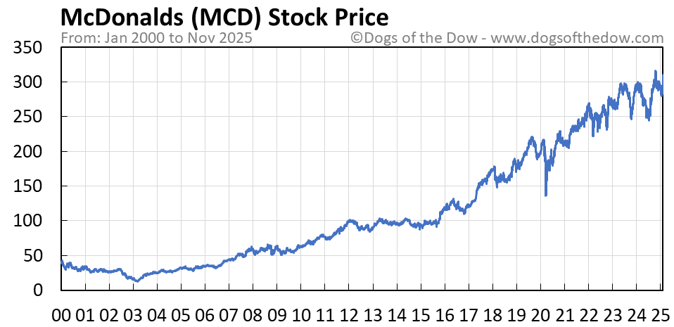
McDonald’s offers one of the clearest examples of why contemporary economics adds little value to long term investing. Over the past several decades, the company has lived through every major economic narrative: high inflation in the seventies, oil shocks, multiple recessions, shifting interest rate cycles, currency swings, geopolitical tensions, and global health crises. Each period came with loud predictions about how the “economic environment” would shape the future of businesses.
Yet McDonald’s continued to do what it has always done. It expanded its global footprint, strengthened its franchise network, improved its supply chain, adapted its menu, and consistently generated stable free cash flow. The long-term compounding in McDonald’s stock did not come from investors predicting inflation or forecasting GDP. It came from understanding the durability of its model and the discipline of its operations.
Any investor who tried to time McDonald’s based on macro trends would have missed decades of value creation. The company’s outcomes were shaped by internal decisions, not external noise. This is the essence of long-term investing: businesses compound, not headlines.

Case 2: Domino’s Pizza

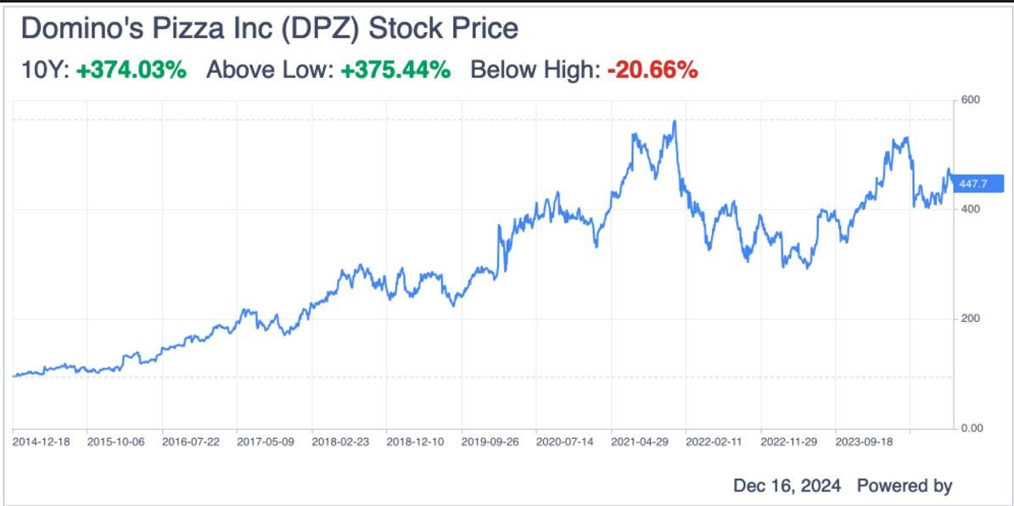

Domino’s is a powerful example of how business execution can overwhelm any contemporary economic concern. In the mid-2000s, the company faced declining relevance and intense criticism for product quality. Then came the 2008 financial crisis, one of the worst economic periods in recent history. Every macro forecast pointed toward reduced discretionary spending and weaker demand for eating out.
Yet Domino’s did the opposite of what the environment seemed to predict. It rebuilt its brand, overhauled its recipes, streamlined operations, and embraced technology long before most competitors understood its importance. Digital ordering, delivery efficiency, and franchise discipline became the pillars of its turnaround.
While the world debated interest rates, unemployment numbers, and consumer sentiment, Domino’s focused on improving the business. The result was one of the most extraordinary compounding stories of the last two decades. Investors who ignored the macro noise and studied the company’s actions were rewarded far more than those who tried to interpret the economic climate.
Domino’s shows that long term performance does not depend on predicting economic conditions. It depends on whether the business itself is evolving, adapting, and allocating capital wisely.

- Conclusion
Investing becomes unnecessarily complicated when investors anchor their decisions to the shifting state of the economy. Macroeconomic forecasts, contemporary headlines, and short-term narratives create the illusion of insight but rarely influence long term outcomes. The businesses behind the stocks, not the economic environment around them, are what compound value over decades.
The examples of McDonald’s and Domino’s show that companies with strong models, disciplined management, and the ability to adapt can thrive across recessions, crises, and policy cycles. Their success was never dependent on predicting inflation or anticipating GDP trends. It came from understanding customers, improving operations, and making sensible decisions year after year.
The goal of this paper has been to show that economics, while intellectually interesting, holds little weight in the actual practice of investing. Contemporary thinking distracts, distorts, and often diminishes an investor’s ability to see clearly. What matters is simple: the quality of the business, the behaviour of the people who run it, and the patience to let compounding unfold.
When investors shift their focus from economies to companies, they trade uncertainty for understanding. They stop reacting and start observing. They stop predicting and start evaluating. And in doing so, they give themselves the best possible chance of building long term wealth.

